DNA Glycosylase Exercise
Background
In this exercise, you will use StarBiochem, a protein 3-D viewer, to explore the structure of a DNA repair protein found in most species, including bacteria. DNA repair proteins move along DNA strands, checking for mistakes or damage. DNA glycosylases, a specific type of DNA repair protein, recognize DNA bases that have been chemically altered and remove them, leaving a site in the DNA without a base. Other proteins then come along to fill in the missing DNA base.
We will begin this exercise by examining the structure of one of the human DNA glycosylases called human 8-oxoguanine glycosylase or hOGG1.
Learning objectives
The structure of hOGG1 will be used to explore the relationship between a protein’s structure and its function.
Getting started with StarBiochem 2.1
- To begin using StarBiochem, please navigate to: http://mit.edu/star/biochem/.
- Click on the Start button Click on the Start button for StarBiochem (Version 2.1).
- Click Trust when a prompt appears asking if you trust the certificate.
- Under Samples, select “1EBM” (the four digit ID for the hOGG1 structure).
Take a moment to look at the structure from various angles by rotating and zooming on the structure.
- Instructions for changing the view of a structure can be found in the top menu, under View -> Structure viewing instructions.
Page 2 contains a series of terms and useful information that you will refer to during this exercise. Briefly, review the terms on this page before proceeding.

Reference
Chemical Structures of the Amino Acids
The 20 amino acids share a common backbone and are distinguished by different side chains, also called ‘R’ groups, highlighted by the various colors below. 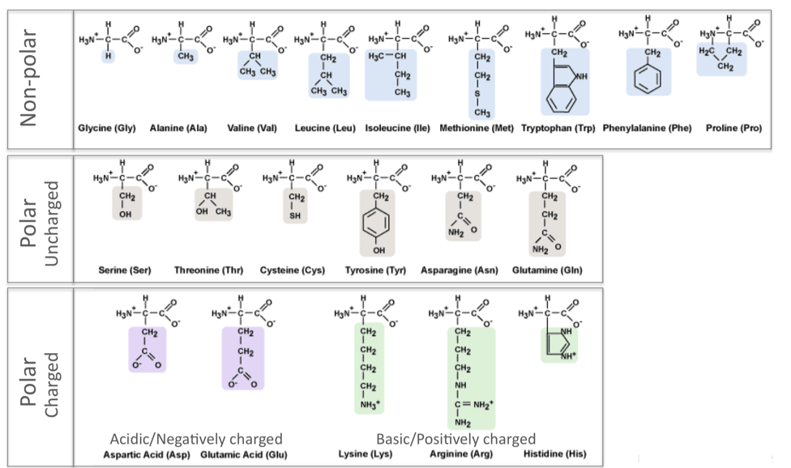
hydrophilic
hydrophobic
PROTEIN STRUCTURE BASICS
All proteins have the following three levels of protein structure:
Primary structure
Describes the order of the amino acids in the protein chain but does not describe its shape.
Secondary structure
Describes shapes that form from local folding of regions within the amino acid chain. These smaller structures can be divided into two main types: helices and sheets. Coils are made of amino acids that do not form regular secondary structures (helices and sheets) but play important roles in protein folding.
Tertiary structure
Describes the entire folded shape of a protein chain.

In addition, some proteins interact with themselves or with other proteins to form larger protein structures. These proteins have an additional level of protein structure:
Quaternary structure
Describes how multiple protein chains interact and fold to form a larger protein complex.
Exercise
The human protein hOGG1 interacts with DNA to help repair damaged DNA bases. In this particular structure, the repair protein is bound to a segment of DNA that has been damaged. We will first focus on the structure of the repair protein and then on how this repair protein interacts with DNA to repair a damaged DNA base.
hOGG1’s Protein Structure Basics
The current way you are viewing the structure is by seeing each atom and bond in the protein drawn as a ball and a line, respectively. This way of representing a structure is called the ball-and-stick model and is the default model in StarBiochem. The ball-and-stick model allows you to see how atoms in the structure bond together. However, the space each atom occupies IS NOT accurately represented. To see a more realistic representation of the atoms in the structure you can use the space-filled model, where each atom is drawn as a sphere, whose size represents the physical space an atom occupies.
You can switch from the ball-and-stick model to the space-filled model in StarBiochem by increasing the size of the atoms in the structure:
- Click on the Primary tab. The default atom size is 20% (ball-and-stick model).
- Move the Atoms Size slider to 100% (space-filled model).
- Notice that different atoms are slightly different in size.
- Gray = Carbon, Blue = Nitrogen, Red = Oxygen, Yellow = Sulfur
1 Can you identify the DNA and the hOGG1 protein in the structure (1EBM)? Where is the DNA segment? Describe in your own words.
Answer

2 hOGG1 contains multiple sulfur atoms.
a) Identify the name and sequence number of one of the amino acids in the structure that contains a sulfur atom.
- Reduce the size of the atoms in the structure back to 20%.
- Using your mouse, zoom in and point to a sulfur atom (yellow) in the structure. A small box appears on top of the mouse curser indicating the name of the amino acid and its position in the amino acid sequence (ex: “[Ala]223:A CB # 2257” → amino acid: alanine; position: 223).
Answer

b) Is the sulfur atom located in the backbone or in the side chain of the amino acid?
- To find if this sulfur atom is in the backbone or the side chain of this amino acid, refer to Reference page 2.
- Optional: From the top menu select View → View Specific Regions / Set Center of Rotation. This will open a smaller window, which enables you to set specific region(s) of the structure visible and centered in the viewer. Follow the steps below to view only the amino acid with the sulfur atom identified above.
- In the Protein → Primary tab select the amino acid identified above in the Sequence Window.
- Move the VDW Radius slider all the way to the left (1 Van der Waals radii). Zoom in as needed.
- First uncheck the side-chain box to hide the side-chain atoms and view only the atoms in the backbone. Next uncheck the backbone box and check the side-chain box to view only the atoms in the side-chain.
Answer

3 Next, we will explore the primary structure of the hOGG1 protein (Reference page 2). The hOGG1 protein consists of 325 amino acids. List the 13 amino acids numbered 105 through 117 in order.
- Reset the structure, from the top menu click, Reset → Reset structure.
- In the Protein → Primary tab scroll down the Sequence Window to locate amino acids 105-117 in the sequence. Refer to page 2 for the complete name of each amino acid.
Answer
105 _______ 106 _______ 107 _______ 108 _______
109 _______ 110 _______ 111 _______ 112 _______
113 _______ 114 _______ 115 _______ 116 _______
117 _______

4 Within a protein chain, amino acids form local structures called secondary structures (Reference page 2).
a) Explore the secondary structures found in hOGG1. Are helices, sheets or coils present in hOGG1 (1EBM)? Describe the color that represents the secondary structures you observe.
- Click on the Secondary tab.
- To show the secondary structures one at a time check the box beside the desired structure (ex: helices) and move the Structures Size slider to the right to increase the size.
- View additional secondary structures that may be present by checking the boxes next to each structure.
Answer
Helices _______ (Yes or No) Sheets _______ (Yes or No) Coils _______ (Yes or No)

b) Amino acids 105 through 117 fold into one of the secondary structures. Which secondary structure do they fold into?
- In the View Specific Regions window, go to the Protein → Secondary tab and click the All button.
- Within the amino acid sequence window, select amino acids 105-117: click on amino acid 105, hold down Shift and click on amino acid 117.
- Move the VDW Radius slider to the right to show only the selected amino acids in the viewer.
Answer

5 Now we will explore the relationship between DNA glycosylase’s structure and one of the several types of amino acids that contribute to hOGG1’s overall shape, its tertiary structure (Reference page 2).
a) Negatively charged amino acids are hydrophilic (Reference page 2). Are the negatively charged amino acids located on the inside (buried) or outside (exposed) of this protein? What does that suggest about the cellular environment surrounding this protein, is it hydrophobic or hydrophilic? Explain your answer.
- In the top menu, under Reset, click on Reset structure.
- Click on the Tertiary tab. Move the Atoms Size slider to the left decreasing size for all the atoms in the protein.
- Click on the negatively charged/acidic button. Move the Atoms Size slider to the right to increase the atom size for the negatively charged/acidic amino acids.
Answer

hOGG1’s Interaction with DNA
6 Now let’s explore how DNA glycosylase interacts with DNA to recognize the damaged DNA base within its sequence. DNA is composed of four bases: Adenine (A), Thymine (T), Cytosine (C) and Guanine (G). In this particular structure (1EBM), the hOGG1 protein is bound to a segment of DNA that contains an oxidized guanine. First, let’s make the DNA segment more visible.
- In the top menu, under Reset, click on Reset structure.
- Click on the Nucleic Acids tab. Move the Atoms Size slider to the right (35%) to increase the size of the DNA segment.
- In the Protein → Primary tab move the Atoms Size slider completely to the left and the Bonds Translucency slider to the right (85%) to minimize the appearance of all the amino acids in the hOGG1 protein.
Second, let’s take a closer look at how the DNA bases are oriented within the double helix. Each base is attached to a sugar and phosphate backbone to form a complete nucleotide. Within the double helix, a base within one strand pairs with another base from the opposite strand by hydrogen bonding forming a base pair: Adenine (A) base pairs with Thymine (T) and Cytosine (C) base pairs with Guanine (G).
a) How many DNA base pairs can you count within this double helix?
- Click on the Nucleic Acids tab.
- Uncheck phosphates and sugars. Move the Atoms Size slider to the left to decrease the size of the bases while leaving the size of the phosphates and sugar nucleotide components intact. This will allow you to count the base pairs more easily.
Answer

b) How many DNA bases are unpaired (not paired to its partner on the other strand)?
Answer

c) Is the oxidized guanine base paired or unpaired? Describe the position of the oxidized guanine with respect to the hOGG1 protein and the double helix. What does this suggest about the mechanism that hOGG1 uses to identify damaged DNA bases?
- Click on the Non-Peptide tab. Move the Atoms Size slider to the right (100%) to increase the size of the atoms in the oxidized guanine ([8OG]25).
Answer

7 Certain amino acids within hOGG1 form contacts with the DNA and are able to recognize if a guanine base has been damaged by oxidation. Where are you more likely to find the amino acids that recognize damaged guanine bases within hOGG1, in Helix 1 or Helix 16? Explain why.
- In the View Specific Regions window click on the Non-Peptide tab. Select the non-peptide, oxidized guanine ([8OG]25).
- Next in the Protein → Secondary tab, click the All button.
- In the Sequence Window, select the amino acids within Helix 1 and Helix 16.
- PC/Linux: Click on the first amino acid of helix 1, Shift+click on the last amino acid of helix1. Ctrl+click on the first amino acid of helix 16, Ctrl+Shift+click on the last amino acid of helix 16.
- Mac: Click on the first amino acid of helix 1, Shift+click on the last amino acid of helix1. Command+click on the first amino acid of helix 16, command+Shift+click on the last amino acid of helix 16.
- Move the VDW Radius slider to the left to show only the selected oxidized guanine and helices 1 and 16 in the image viewer.
- Optional: This set of steps will allow you to see if any of the side chains within Helix 1 or Helix 16 contact the oxidized guanine ([8OG]25). In the main window, click on the Protein → Primary tab. Uncheck backbone. Move the Atoms Size slider to the right to visualize the side chains of the amino acids helices 1 and 16.
Answer

